EXPERIMENT NO. 9
Hospital Information System for SIMATS Hospital using Zoho Creator (SaaS)

Aim
To develop a cloud-based Hospital Information System for SIMATS Hospital using Zoho Creator to manage patient information and demonstrate Software as a Service (SaaS).

Objective
• Create a hospital information application.
• Store patient and attender details.
• Maintain doctor and disease information.
• Generate reports.

Software Requirements
• Zoho Creator
• Google Chrome
• Internet Connection
• Deluge Script (optional)

Theory
The Hospital Information System is a cloud-based SaaS application that stores patient records securely. It maintains patient details, contact information, attender details, doctor details and disease information. Zoho Creator enables easy form creation, cloud storage and report generation.

Fields Used
Patient Name, Age, Address, Phone Number, Email, Attender Name, Attender Phone, Doctor Name, Disease.

Algorithm
1. Start
2. Open the Hospital Information form.
3. Enter patient details.
4. Enter attender and doctor details.
5. Enter disease information.
6. Save the record.
7. Generate report.
8. View individual record.
9. Stop.

Procedure
1. Login to Zoho Creator.
2. Create the Hospital Information System application.
3. Design the form with required fields.
4. Save the form.
5. Enter sample records.
6. Create a report.
7. Verify the output.

Observation
• Patient details were entered successfully.
• Attender and doctor information was stored correctly.
• Hospital records were saved in the cloud database.
• Reports displayed all patient records.
• Individual record view displayed complete patient information.
• The application functioned correctly.

Result
The Hospital Information System was successfully implemented using Zoho Creator. Patient information was stored and reports were generated successfully.

Conclusion
The experiment demonstrated the implementation of a SaaS-based Hospital Information System using Zoho Creator.

Output Screenshots
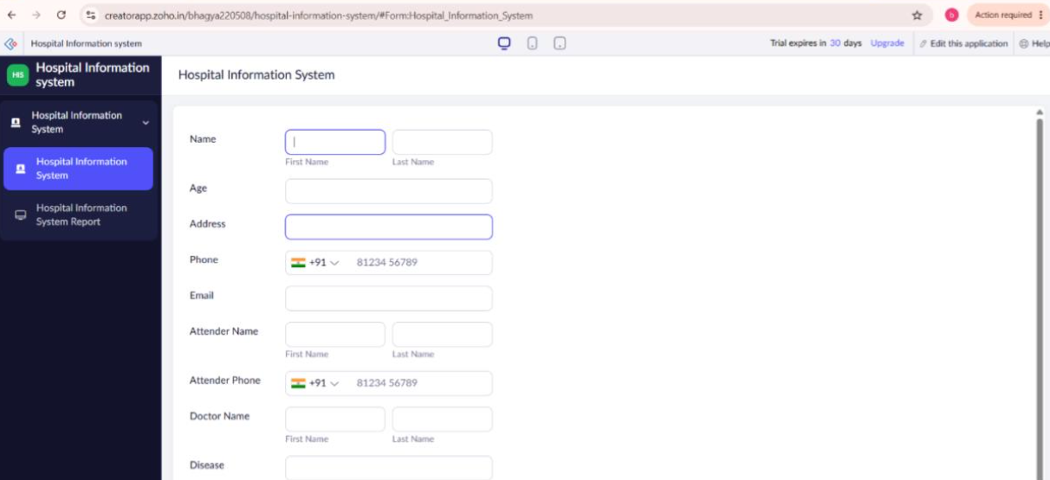
Figure 1: Hospital Information Form
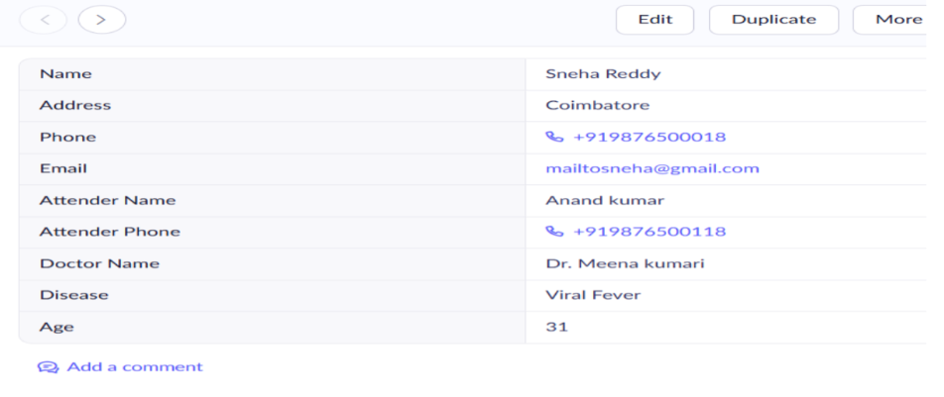
Figure 2: Individual Patient Record
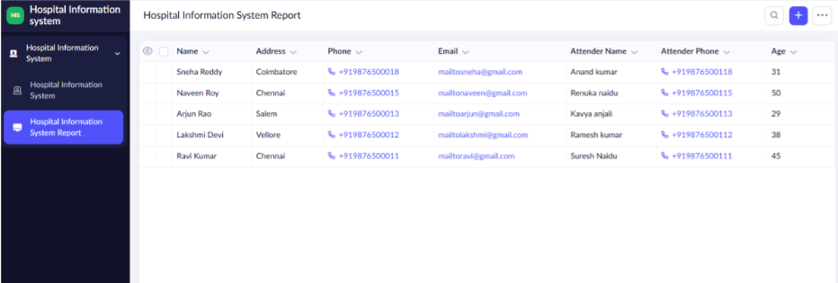
Figure 3: Hospital Information Report

